|  |  |
| --- | --- |
| Date | 21 June 2025 |
| Name | Shambhuraj Jaysing Patil |
| Project Title | Restaurant Recommendation System |
| Maximum Marks | 10 Marks |

Initial Model Training Code, Model Validation and Evaluation Report Initial Model Training Code (5 marks):

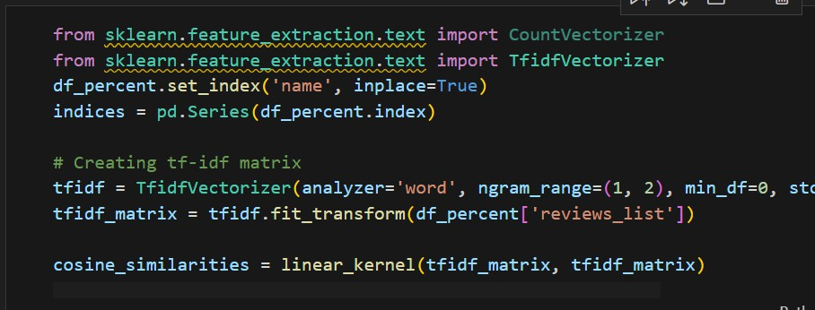

Model Validation and Evaluation Report (5 marks):

|  |  |  |
| --- | --- | --- |
| **Model** | **Summary** | **Training and Validation Performance Metrics** |
| Model 1 | Content-based Recommendation | **Training Metrics -**None (unsupervised, no explicit training phase)  **Validation Metrics -** None (recommendations are inspected manually) |